

Quality Policy
©This document is the property of Vietec Limited

Approval & Authorisation


Authorised by: Philip Drew
Managing Director
Vietec Limited

Reviewed by:

Phil Drew – NEBOSH
Managing Director
Date: 06.02.26

CONTENTS
Section:
_____________________________________________________________
Part A: Issue Record
Implementation
Review
_____________________________________________________________
Part B:
1 Introduction
2 Purpose
3 Scope
4 Definitions
5 Quality Policy Accessibility
6 Document and Change Control
7 Managing Directors Quality Policy Statement
8 Organization Chart
9 Responsibilities
10 Sub-Contractor Policy
11 Management Review
12 Contract Review
13 Design Control
14 Purchasing & UKCA / UK (NI) Marking Compliance
15 Process Control
16 Inspection and Testing
17 Continuous Improvement
18 Handling and Delivery
19 Records
20 Training & Competence
21 Appendices

REFERENCES
• Working at Height Policy
• Environmental Policy
• Managing Contractors Policy

PART A

Issue Record | This Company Policy will be updated when necessary and recorded on the revision record below.  Amended or additional parts of revised pages will be marked by a vertical black line in the adjacent margin.  Issue Date Comments  1 August 10 Original Document  2 September 11 Updated minor changes  3 February 14 Updated minor changes  4 February 15 Updated minor changes  5 March 16 Updated minor changes  6 April 2019 Full Review  7 June 2020 Annual review  8 June 2021 Annual review  9 December 2022 Annual review  10 January 2023 Updated minor changes  11 August 2023 Annual review  12 September 2023 Update to Org Chart  13 May 2024 Update to Org Chart  14 August 2025 Update to Org Chart & CO role  15 February 2026 Update to 14, 16 & 20
Implementation | Implementation shall commence from date of receipt.
Review | This policy will be reviewed annually and when any significant event or reorganisation occurs.

PART B

- INTRODUCTION
Vietec Limited was formed in August 2005 to provide wireless voice and data networking solutions to industry.

This Quality Policy is mandatory and applies to all products and services carried out by Vietec Limited, employees and sub-contractors.

Vietec Limited are the premier integrator of wired and wireless technologies. By working directly with the world's leading manufacturers, we position ourselves as an extension to our clients organisation (Public, Private and Education sectors) within the solutions delivery chain.

Staff at all levels are committed to following the requirements of the Quality Policy and fully understand the obligations within their own areas of work. They are totally involved in the operation of the system and are encouraged to suggest improvements.

Improved performance is driven by setting quality objectives for improvement, which are agreed between VIETEC Top management and project, and process leads. Regular monitoring by internal auditing and management review ensures its continuing stability and effectiveness including reviewing stakeholder feedback. Actions are taken to improve and maintain the dynamic status of the system are set based on an assessment of business risk.

In order to provide an on-going commitment to the customer’s needs, the organisation shall continually review and implement such changes as is necessary to new capabilities and facilities.

- PURPOSE
The purpose of this Quality Policy is:
- To identify the structure, process, techniques and to enable Vietec to provide high quality products and services;
- To ensure there is a standardised approach to all training requirements and certification of employees and sub-contractors.

- SCOPE
The scope of this policy shall apply to all of Vietec Limited’s organisation, company locations, activities, employees, sub-contractors and when visiting and/or work is being carried out at a client premises.

- DEFINITIONS
Site: Any location, other than the company’s established premises where work is undertaken as part of or in advance of a formal contract.
Employee: Any member of staff employed directly by and representing Vietec Limited.

Sub-Contractor: Any engineer employed by Vietec for the duration of a contract and representing Vietec Limited.

- QUALITY POLICY ACCESSIBILITY
This Quality Policy shall be communicated to all employees and sub-contractors with a responsibility for the supply of Vietec products and services.

It shall be made available to clients and potential clients for information

- DOCUMENTATION & CHANGE CONTROL

All company documentation is controlled to ensure:

- It is issued to the appropriate personnel;
- Is under the correct level of authority;
- Revised as and when required;
- Reissued as necessary;
- Obsolete versions are removed from the point of use.

Such documentation typically includes:

- Policies;
- Procedures;
- Specifications;
- Customer Orders;
- Plans/ Drawings;
- Quality Assurance Manual;
- Health & Safety Statements;
- Risk Assessments;
- Methods of Work

- MANAGING DIRECTOR’S QUALITY POLICY STATEMENT

It is my policy to provide quality services which consistently satisfy the needs and expectations of our customers while achieving sustained profitable growth.
This level of quality is achieved through the execution of policies and procedures that will highlight the competence of the company to existing customers, potential customers, and auditing authorities both internally and externally.
All staff and sub-contractors are responsible for the implementation and adherence of this Policy and associated procedures where relevant to their work. In adhering to this Policy my aim is to provide continuous improvement in the quality and efficiency of all products and services we offer at Vietec.
To achieve and maintain the required level of assurance Vietec Limited shall ensure that the Quality System is managed and adhered to at all time.

I believe the objective of our Quality Policy is to:
- Maintain an effective Quality Assurance System.
- Achieve and continually develop a level of quality which enhances the Company’s reputation with customers.
- Ensure compliance with all relevant statutory and safety requirements.
- Endeavour, at all times, to maximise customer satisfaction through the services provided to them by Vietec.
I am personally committed to provide our employees and customers with the highest quality of service.

Philip Drew
Managing Director 06.02.26
Vietec Limited

ORGANISATION CHART

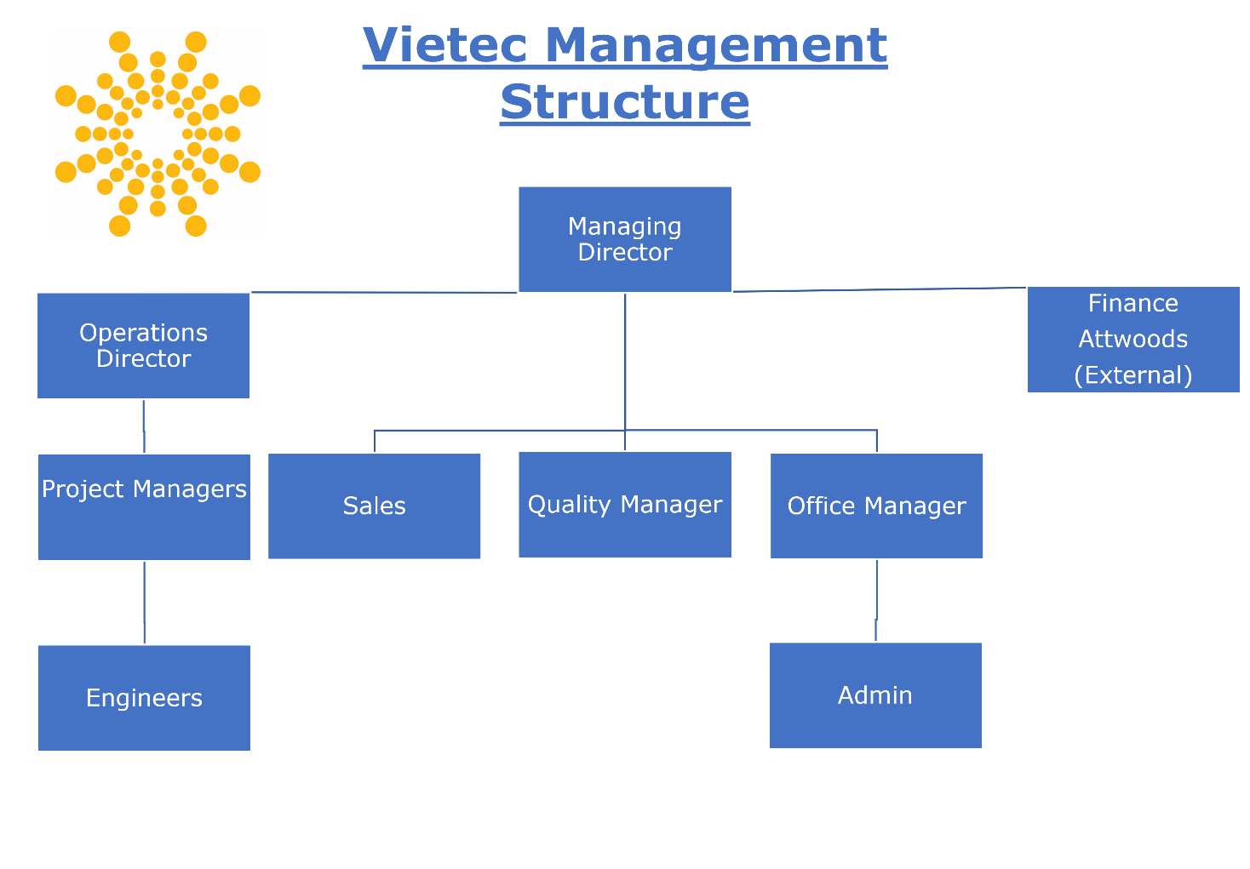
- RESPONSIBILITIES

  - Introduction
    - All employees and sub-contractors shall perform their allocated responsibilities in a professional manner and in compliance with this Policy.

    - All employees and sub-contractors shall be responsible for identifying hazards and nonconformance to the company’s policies and procedures. They shall ensure they are reported such that corrective action can be taken to rectify the issue and prevent re-occurrence.

    - All employees and sub-contractors are expected and encouraged to identify improvement opportunities in line with this Policy.

    - The Vietec senior team shall continuously review the resource levels of the company to ensure that adequate staff, equipment and materials are available to meet the customer requirements.

  - Managing Director
The Managing Director shall be responsible for:
- The approval and maintenance of the Quality Policy;
- Accountable for the overall performance and compliance of the company to all applicable legislation;
- Conducting an annual review of the Quality Policy and his personal Policy Statement;
- Approval of the Quality Policies and associated documentation;
- Provision of insurance in line with company and statutory requirements
- Management of sales and marketing
- Supplier selection and approval
- Purchasing of all tools, equipment and services;
- Contract management and control
- Project management

  - Operations Director
The Operations Director shall be responsible for:
- The planning and performance of all technical activities;
- Repairs, testing and maintenance activities;
- Control of equipment and materials used by Vietec Limited;
- Design control;
- Project management.

  - Office Manager
The Office Manager will coordinate with the Managing Director and the Company Accountants and be shall be responsible for:
- Control of finance and accounts;
- Control of statutory obligations with regards money and tax regulation;
- Control of English law obligations;

9.5 Quality Manager
The Quality Manager shall be responsible for:
- Conducting the internal audit schedule and identify areas of non-compliance throughout the business
- Managing the training, organization, scheduling and task assignment for auditing staff
- Maintaining knowledge on all required regulations and design required training for compliance procedures
- Analyzing potential risks within the company and its practices to avoid compliance issues
- Ensuring all quality documents are controlled, managed & maintained in accordance with the standards

9.6 Sales Team
The Sales Team shall be responsible for:
- Present, promote and sell services/ products to existing and prospective customers
- Establish, develop and maintain positive business and customer relationships
- Achieve agreed upon sales targets and outcomes within an agreed schedule
- Expedite the resolution of customer problems and complaints to maximise satisfaction
- Coordinate sales effort with team members and other departments

9.7 Project Managers
The Project Managers shall be responsible for:
- Determine and define project scope and objectives
- Predict resources needed to reach objectives
- Track project costs in order to meet budget
- Develop and manage a detailed project schedule
- Monitor progress and make adjustments as needed

9.8 Engineers
The Engineers shall be responsible for:
- Installing network infrastructure not limited to the following (data cabling, fibre optics, CCTV, door access, audio visual)
- Ensure all work is finished in an efficient and proper manner in accordance with company standards and protocol
- Assist in upholding excellent site security, at all times
- Delivery and collection of assets and materials
- Report any observed unsafe acts, near misses and positive observations

- Sub-Contractor Policy
10.1 Introduction

It is the policy of the Vietec Limited to engage the employment of sub-contractors for working on site.

Vietec Limited shall administer a strict Approval of Contractor Policy to ensure that all aspects of this quality policy are met in full.

  - Supplier Selection
Suppliers are selected on their ability to meet contract requirements. The type and extent of control exercised on suppliers is defined in the Managing Contractors Policy VT-HS01/5.

- Management Review
Vietec Limited shall carry out a management review annually or when the need is identified to test the sustainability and effectiveness of the Quality Policy and Management System.

The objective of the management review shall:
- Establish the Quality Policy and Management System is:
- Achieving the expected results and meeting the company’s and customer’s requirements;
- Continuing to conform to the Policy;
- Continuing to satisfy the customer’s needs and expectations;
- Functioning in accordance with the company procedures.
- Expose irregularities or defects in the company processes, identify weaknesses and evaluate possible improvements.
- Review the effectiveness of all corrective actions; to ensure their adequacy and suitability of for present and future operations of the Company.
- Review any customer complaints received by Vietec Limited, to ensure the cause was correctly identified and remedial corrective actions implemented were to the total satisfaction of the client.
- Review the finding of audits (internal and external) to identify any areas of recurring problems (trends) or potential improvements that Vietec Limited can make to their Quality Policy and Management System.
- Review reports of non-conforming items and trend information to identify possible improvements to how Vietec manage their business.

- Contract Review
Vietec Limited offers both standard and specialist services to meet each customer’s needs.

Service requirements differ from one customer to another (and from one contract to another); therefore, all services provided are tailored to meet the specific requirements of the client.

Where a proposal is accepted by the customer and on receipt of a Purchase Order (PO), all information relating to the contract is recorded. The Scope of Work shall be reviewed to ensure the requirements of the client are adequately and clearly defined. Vietec Limited where necessary shall ensure the Scope of Work is agreed with the client before proceeding with the contract requirements.

The client may at any time request a variation to the contract. Any variations would be required in writing to ensure a full understanding of the client’s requirements is understood. All costs, timescales and changes to the Scope of Work associated with the variation shall be agreed prior to proceeding with the work.

Please refer to Appendix 4 for the current Sales Process (S12).

- Design Control
Design activities is typically delivered in house with the assistance of specialist vendor distributors where necessary.

The management team shall review and approve all designs prior to and with Vietec Limited clients.

- Purchasing & UKCA / UK (NI) Marking Compliance
A list of Approved Suppliers (Approved Supplier’s Register) shall be maintained by Vietec Limited.

All products, materials and services, where unspecified by a customer contract, are selected on their ability to meet the company’s requirements. Due consideration to quality, statutory obligations, time scale and cost shall be given.

Suppliers shall be selected where:

- A valid DBS check has been completed
- Previous performance in supplying good and services are to similar specifications and requirements;
- Recommendation by other similar purchasers or manufacturers of equipment has been received by Vietec Limited;
- A trial order and evaluation of their performance has been carried out.
- All correct certifications are in place to enable the services to be undertaken. The minimum standards will be CSCS/ECS, 1 day H&S, asbestos awareness, working at heights, manual handling.

All Purchase Order’s shall provide full clarification of the type and extent of the goods and services to be purchased. Purchase Order’s shall in all circumstances be approved and correctly authorized before the goods and services are purchased.

Should a supplier who is not on the Approved Suppliers Register be proposed, they will be reviewed and authorized as an Approved Supplier by a Company Director. He shall authorize the status as an Approved Supplier only when he is fully satisfied all the requirements of the Quality Policy and System has been met.

Please refer to Appendix 5 for the current Project Process (O28)

Verification of UKCA or UK(NI) Marking
As part of our quality assurance and procurement procedures Vietec Limited confirms the following:

We ensure that all products we purchase and use comply with current UK regulatory requirements.

Our checks include:
• Confirming that all applicable products display the correct UKCA or UK(NI) marking.
• Reviewing product labels, packaging, and supplier documentation (e.g., Declarations of Conformity) before approval.

Supplier Compliance Checks
All of our suppliers are UK‑based and as part of our supplier vetting process, we confirm that:
• They supply products that meet UKCA / UK(NI) requirements.
• They provide the necessary compliance documentation where required.
• They follow UK legislation for conformity assessment and product safety.

Because we only use reputable UK suppliers, there is no requirement for overseas compliance checks.

Use of Compliant Products Only
We confirm that only products with the appropriate UKCA or UK(NI) marking are used within our company. Any product that cannot demonstrate compliance is rejected.

In addition, we further facilitate this by partnering with reputable, established manufacturers who all comply with these standards such as:
• Excel
• Axis
• ViewSonic
• HP Aruba

Self-Marked Products
Our company does not manufacture or self-mark any products.
Therefore, this requirement is not applicable to our operations.

- Process Control
All productive work shall be planned and undertaken in accordance with the company's policies and procedures.

Contracts, cost, timescales, specifications, methods of work and any specific documents shall be agreed with the client prior to undertaking the work.

Variations to an agreed scope of work shall be administered in accordance with the company procedure and agreed with the client prior to the change being implemented.

Vietec Limited shall ensure its employees and sub-contractors fully comply with the client’s requirements whilst on their premises.

Employees, sub-contractors and other representatives of Vietec Limited shall receive a site safety induction before commencing their work. Records shall be kept that are traceable, legible and accurate showing site safety briefs have been carried out.

- Inspection and Testing
Inspection and testing shall be carried out on completion of installation and maintenance activities by a competent member of our team. For more information on how we assess our team’s competence please see section 20. Vietec Limited shall ensure all statutory requirements are fully met for the installation and as set out in the scope of work document.

Where any equipment fails its inspection and testing, Vietec Limited shall ensure the equipment is repaired, replaced or specific actions are taken after consultation and agreement with the client.

On completion of installation and/or maintenance works, the customer shall be invited to check the work performed fully conforms to the agreed scope of work. On satisfactory completion of the installation and/or maintenance work, Vietec Limited and the client shall jointly sign off a Job Sheet Sign Off Form O13 (see Appendix 3 for the first page of this document).

- Continuous Improvement
All Vietec Limited employees shall be encouraged to suggest improvements in methods of work, tools, equipment, materials, suppliers, and sub-contractors.

Vietec Limited shall continuously monitor the quality of all work undertaken on behalf of its clients.

Vietec Limited shall ensure a minimum of two on-site inspections per year are carried out to identify any advancement in the Company that can be implemented to improve:
- The health, safety and welfare of its employees and sub-contractors;
- The products and services provided to its customers;
- The Company policies and procedures.

All inspections shall be recorded on an In Process Inspection Sheet (see Appendix 1).

Vietec Limited shall retain accurate, legible and traceable records of all In Process Inspections carried out (see Appendix 2).

Internal audits shall be conducted each year in regard to health & safety, quality and information security to further analyze performance and processes.

- Handling and Delivery
All materials and goods received, whether the property of the company or others, will as far as practicable shall be protected and their quality preserved until such time as they are transferred to a customer’s premises.

When practicable, materials and goods shall be ordered to align with the commencement of each contract. This shall minimize any risk of deterioration of the material and goods to optimize the technical reliability of the customer’s installation.

Where possible equipment installed for a client shall be tested and configured at Vietec Limited premises. This shall ensure the material and goods are working correctly and to defined specifications to remove risks to the agreed contract and Vietec Limited customers

- Records
All records produced by Vietec Limited shall be accurate, legible and traceable.

Vietec Limited shall provide storage facilities to ensure that all stored records are identifiable and easily retrievable. Storage areas shall be free from damp and other agents which could cause premature deterioration of the documentation.

Where records are maintained on computer magnetic media, a "back-up" at regular intervals of the records shall be carried out and stored in a protected location to ensure security from loss and/or damage of active data.

Vietec Limited shall retain records for a minimum of 2 years or in-line with customer requirements

Where records are no longer required, all documentation shall be destroyed in a manner that protects and provides confidentiality for the Company and its clients.

- Training & Competence
Vietec Limited shall ensure all employees and sub-contractors are trained, experienced and competent to undertake their responsibilities effectively in accordance with all statutory and mandatory requirements.

A person is considered competent when they have the following:
- The appropriate qualifications and mandatory certifications for their role (e.g. CSCS/ECS, Working at Heights, Asbestos Awareness, Manual Handling)
- The required technical and manufacturer specific training relevant to the systems they install
- Sufficient industry experience to carry out the task safely and to the required standard

All employees and sub-contractors shall be responsible for recommending any additional training needs that would improve their safety, technical ability and be beneficial to the Company and/or its clients.

Vietec identifies and records these within our company Skills Matrix which is maintained and regularly reviewed to ensure our team meet the necessary skills, training & competency standards for the work they undertake.

- Appendices
Appendix 1
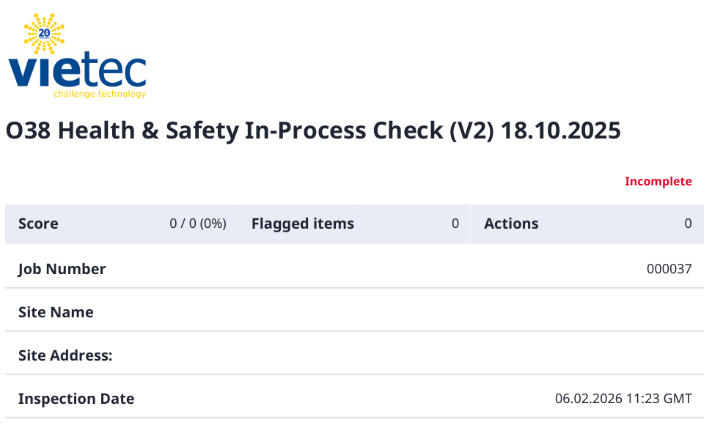

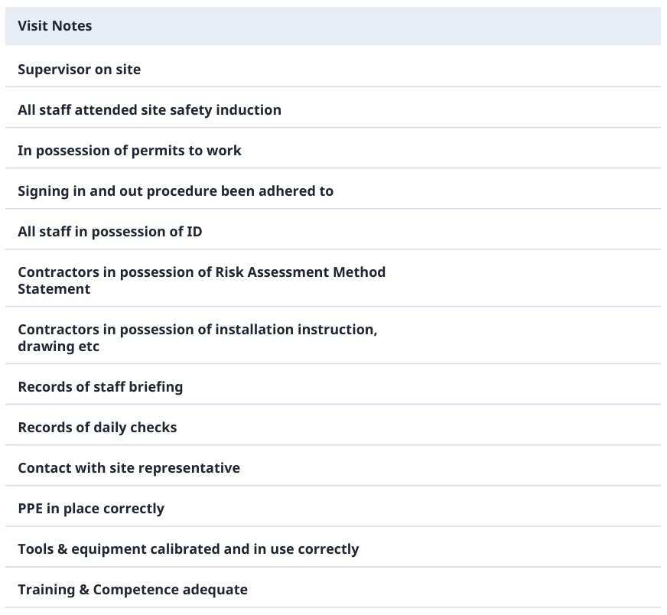

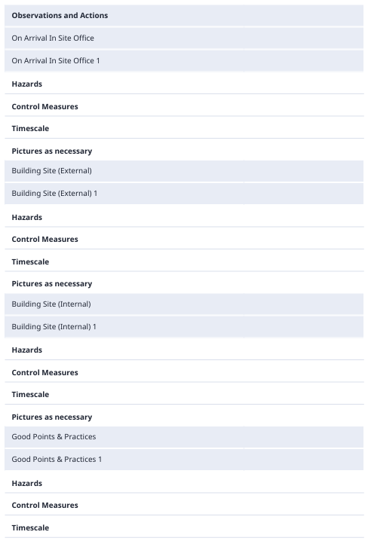

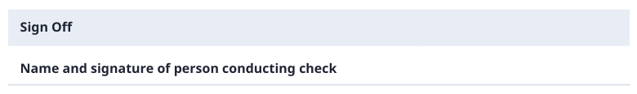
Appendix 2
Record of In Process Inspections

Date | Contract Number | Carried out by

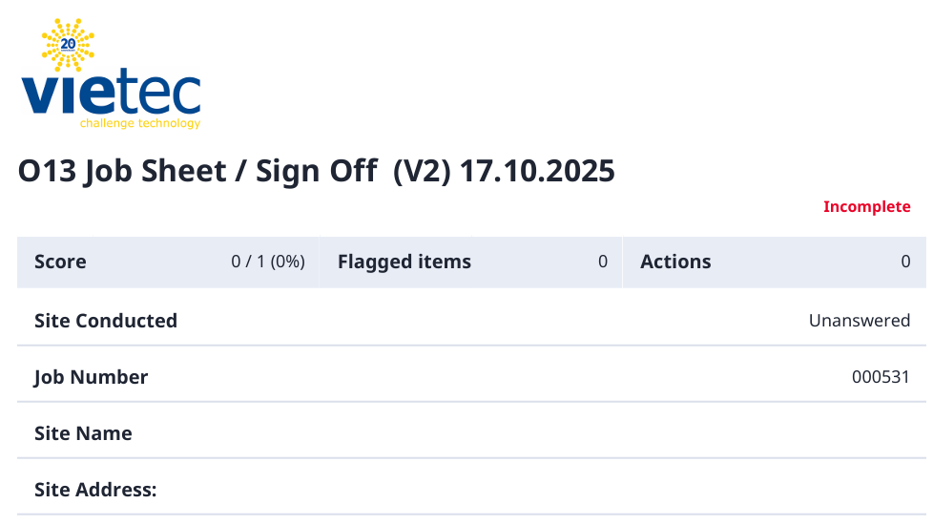
Appendix 3
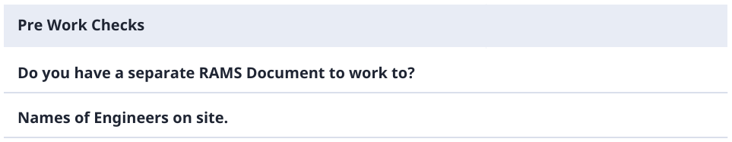

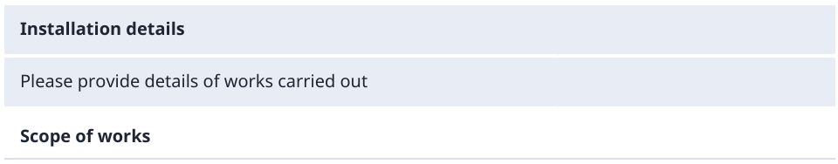

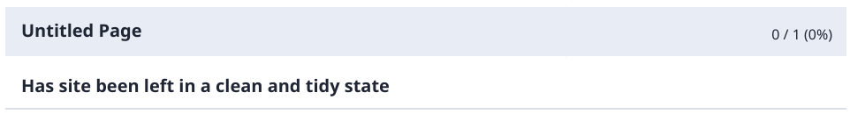

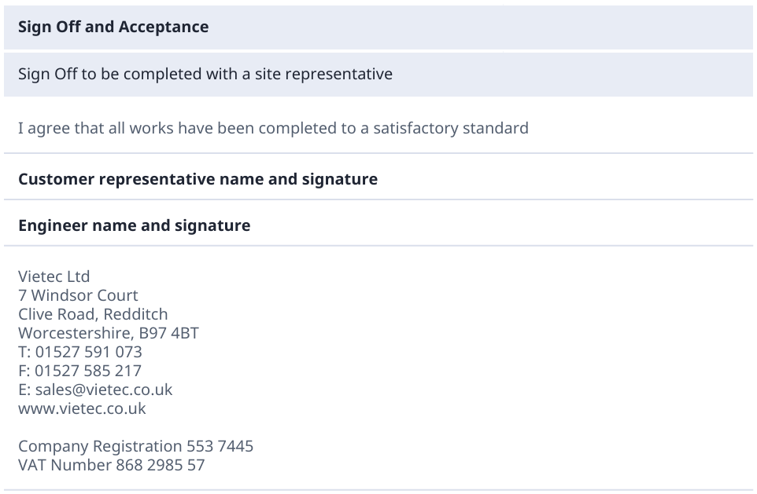

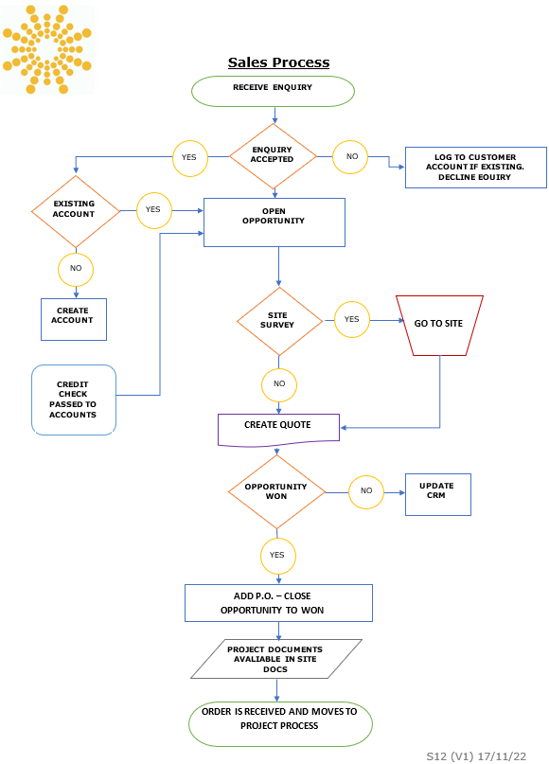
Appendix 4

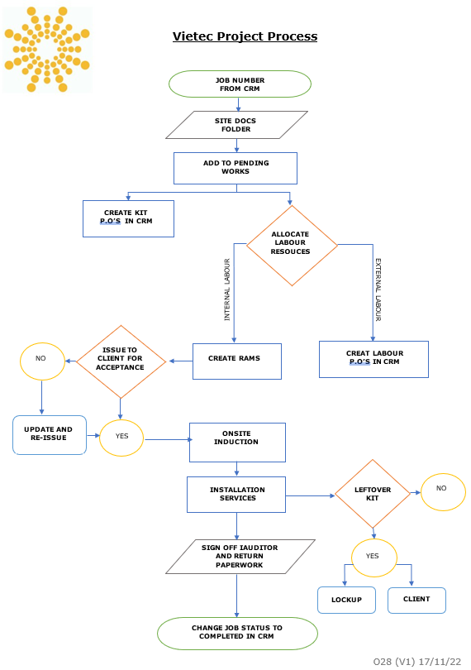
Appendix 5

