Modern Slavery Transparency Statement 2025

The majority of vietec’s suppliers are based in the same country of operation. The UK was identified as one of the countries with the lowest percentages of its population in modern slavery (Global Slavery Index 2018 Dataset, Walk Free Foundation, available from www.globalslaveryindex.org) and with the UK Government rated globally as taking the most action to respond to modern slavery (Measurement Action Freedom report, Minderoo Foundation, available from www.globalslaveryindex.org).

Policies and Procedures
vietec complies with the employment laws of the UK and expects all those with whom it does business to do the same. Suppliers who do not show high ethical and wider Corporate Social Responsibility standards or compliance will be excluded from any tendering process. vietec is committed to supporting anyone who raises genuine concerns about Modern Slavery even if they subsequently prove to be unfounded.

Responsibility
Responsibility rests with us all. All individuals working for vietec, in every capacity, are expected to be familiar with the Modern Slavery Statement, and be proactive in preventing Modern Slavery. This includes employees at all levels, directors, officers, agency workers, seconded workers, volunteers, interns, agents, contractors, external consultants, third party representatives and business partners. vietec ensures that it meets National Living Wage as a minimum, and pays its external contractors a competitive rate.


Philip Drew
Managing Director

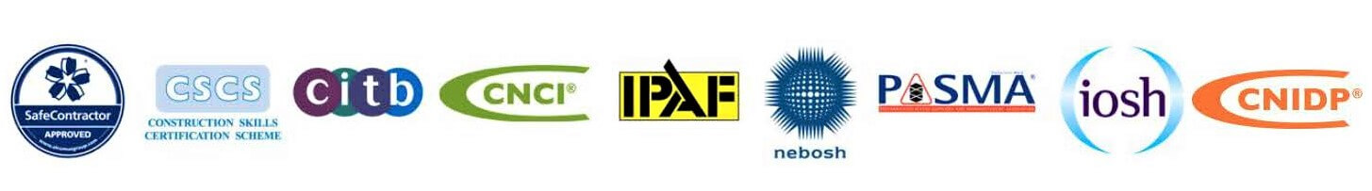
Date: 06.11.25

